 |  |  |  |  | Scenario factors
ID | Usage phase | Operation mode | Exposed person | Task/Action | Danger | Danger zone | Dangerous situation | Dangerous event
1
2
3

Risk assessment of inventoried hazards |  |  |  |  | Kies een risico-inschattingsmethodiek:
 | Explanation / substantiation |  |  |  | 14-punts risicograaf |  |  |  |  |  | Hybride methode |  |  |  |  |  |  | Kinney en Wiruth
ID | Severity | Frequency | Probability | Avoidability | Se | Fr | Pr | Av | R |  | Se | Fr | Pr | Av | (Cl) | R |  | Se | Fr | Pr | R
1
2
3

Please note: A substantiated risk assessment must be carried out for each risk for which the risk assessment can be used as input.

Risk assessment methodology: 14-point Risk Graph
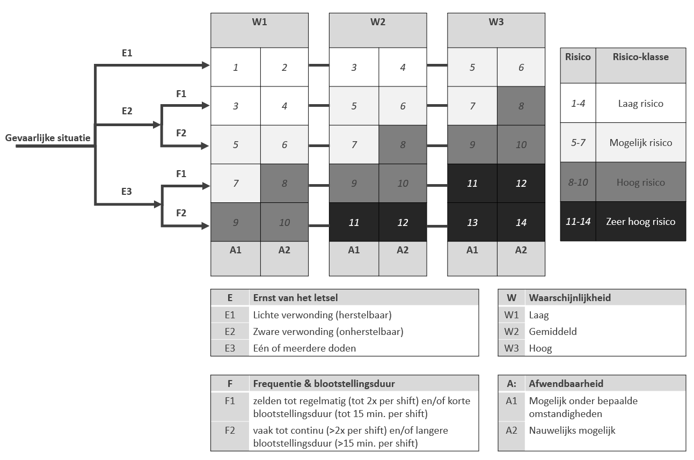

Risico-inschattingsmethodiek: Hybride methode
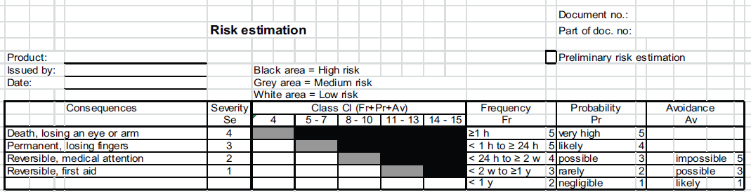

Risk assessment methodology: Kinney en Wiruth
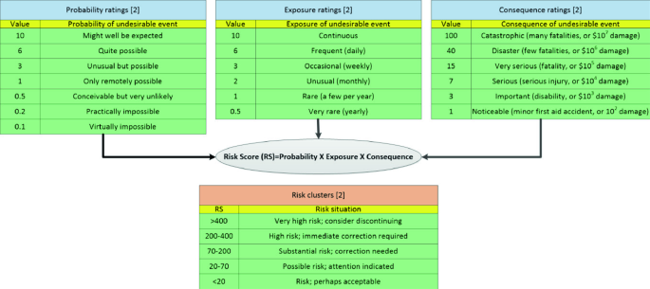

Risk-reducing measures
ID | Step 1  Inherent measure | Step 2a  Security / Shielding | Step 2b  Identification of any safety function | Step 3a  Information on/by machine | Step 3b  Information in the user manual | Risk-evaluation  (residual) risk acceptable? | Incorporating measure into design (docnr.)
1
2
3

